Social Media Legal Reel Automation
n8n | Gemini | JSON2Video | Google Sheets | JavaScript

Project Overview

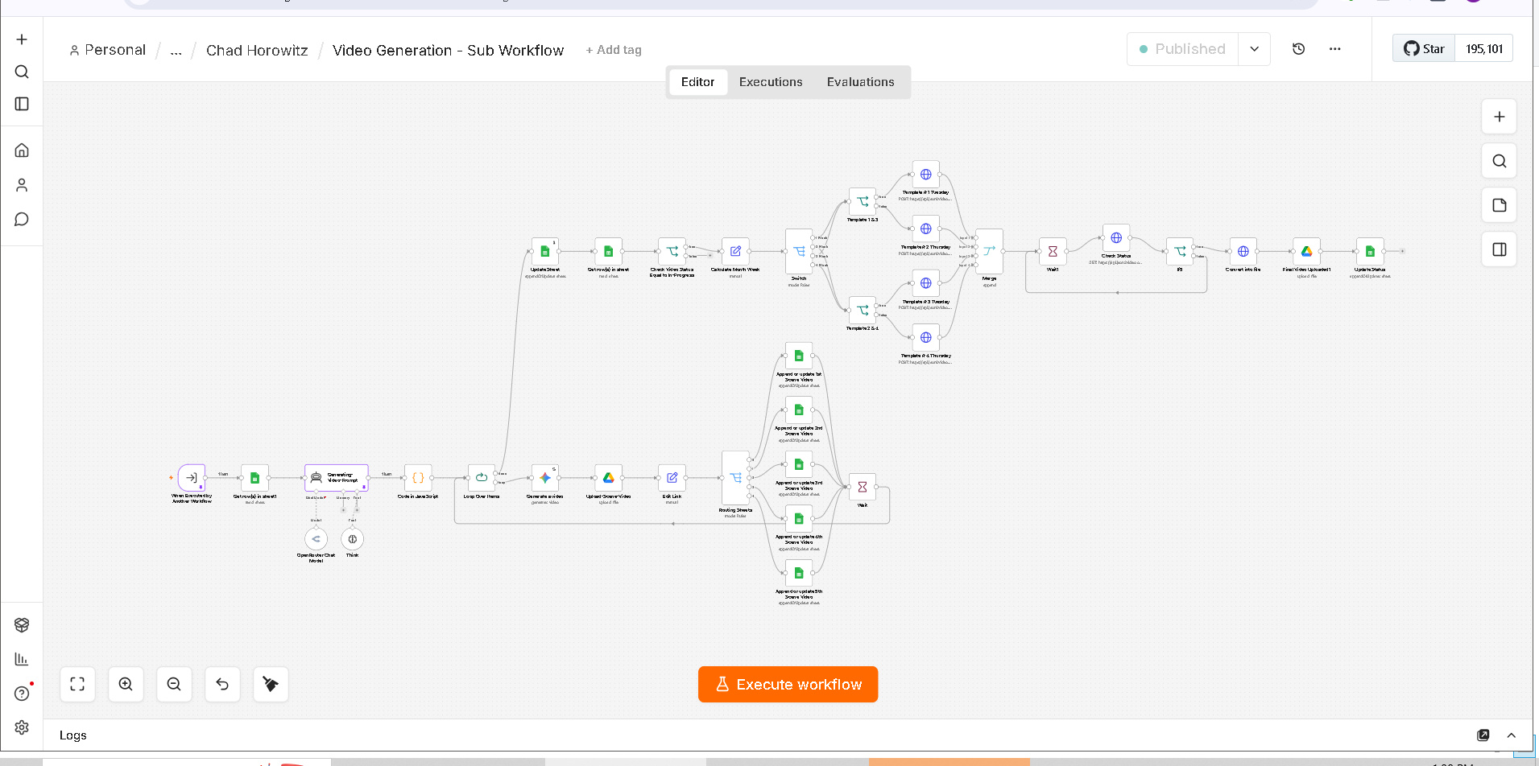

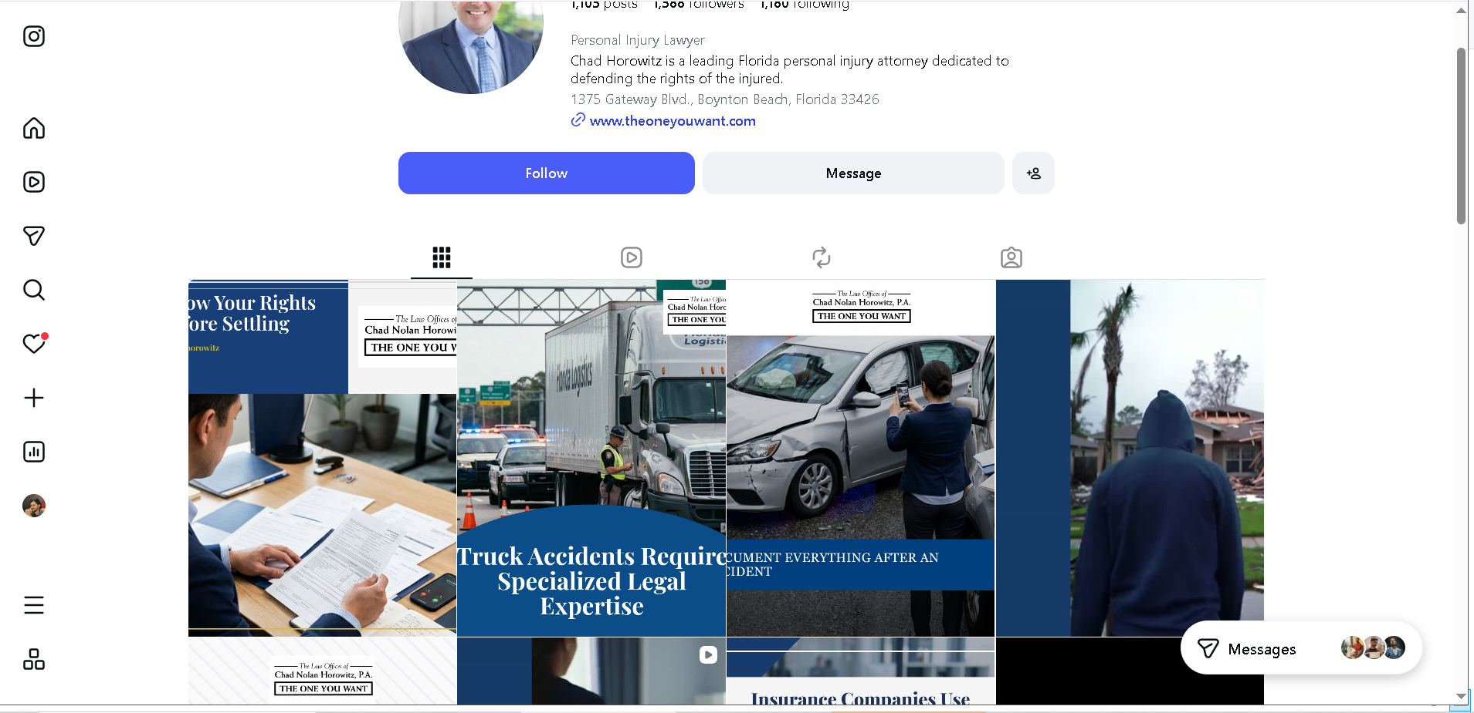
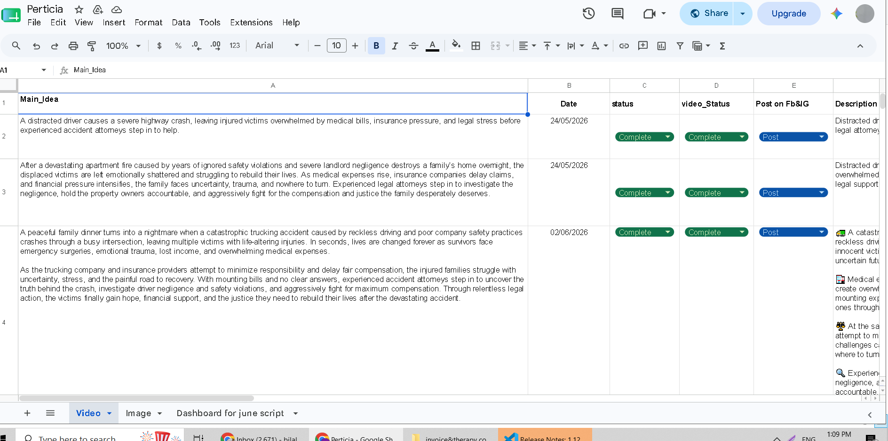
Built an automated content system for producing branded legal reels for Facebook and Instagram.
The workflow takes an approved content idea and turns it into a complete short form video with the script, visuals, captions, hashtags, and branding handled automatically.

Workflow
The system:
• Retrieves approved content ideas from Google Sheets
• Generates the reel script and scene structure
• Creates the required video scenes
• Formats scenes for vertical social media content
• Combines the scenes into one video
• Adds branding, logo, text overlays, transitions, and music
• Generates the caption and hashtags
• Updates the content status
• Stores the finished video reference in Google Sheets

Content Generation
Each reel includes:
• Scene by scene structure
• Visual directions
• Text overlays
• Social media caption
• Relevant hashtags

Technology
• n8n
• Google Gemini
• JSON2Video
• Google Sheets API
• JavaScript
• REST APIs

Result
A complete content production workflow that turns an approved idea into a branded, social media ready legal reel with minimal manual editing.
The system makes it easier to produce consistent content at scale while keeping the entire process organized in one workflow.

